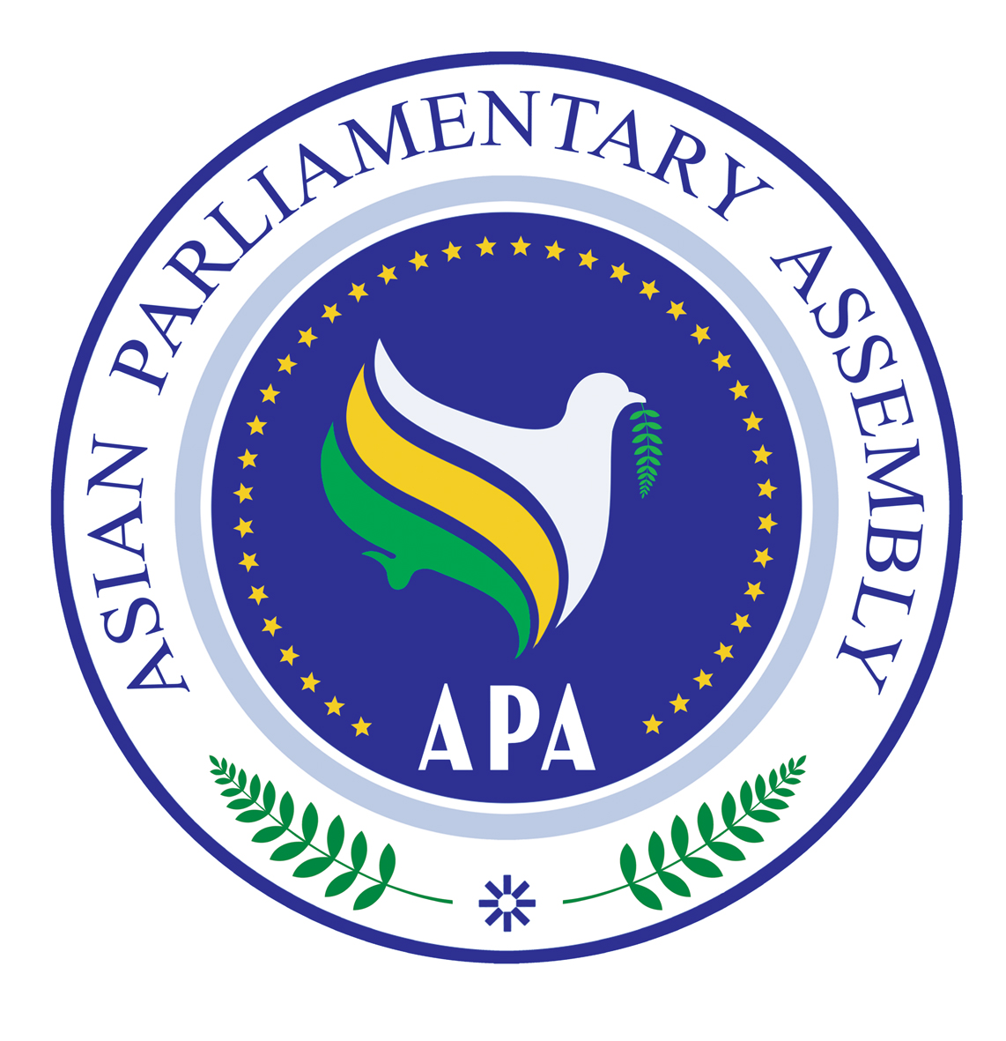
Asian Parliamentary Assembly

APA Troika/Rep/2010/01
1 June 2010

Report of the "APA Troika Plus" Meeting
On
the Atrocities of the Zionist Regime in Palestine

1 June 2010
Tehran

1. The APA Troika Plus on the atrocities of the Zionist regime in Palestine held its meeting on 1 June 2010 in Tehran, the Islamic Republic of Iran. The meeting was opened at 14:15.
Honorable, Dr. Marzuki Alie, the APA President and the Speaker of the House of Representatives of the Republic of Indonesia chaired the meeting. Honorable, Mr. Mahmud Al-Abrash, the Speaker of the People’s Assembly of the Arab Republic of Syria, Honorable, Dr. Ali Larijani, the Speaker of the Islamic Parliament of Iran and Honorable, Mr. Tayseer Qubaa, the Deputy Speaker of the Palestine national Parliament and Honorable, Mr. Amanullah Paiman, the Deputy Speaker of the Parliament of Afghanistan participated in this meeting. List of participants is attached as Annex - I

2. Deputy Speaker of the Iranian Parliament, Honorable, Mr. Hassan Aboutorabi Fard read the message of Ayatollah Khamenei, the Supreme leader of the Islamic Republic of Iran, on the occasion of the attack by the Zionists against the humanitarian aid flotilla heading towards Gaza. Ayatollah Khamenei stated that the criminal and barbaric attack by the Zionists against the humanitarian convoy is yet another example of heinous crime against the Muslims in the region particularly the Palestinians. This criminal attack should convince all that Zionism is a new and more violent form of Fascism. The U.S., U.K. and France and other European countries which have extended their political, media, military and economic supports to the Zionist regime and have always backed these criminal deeds should be seriously held accountable. Palestine is neither an Arab nor a Muslim issue anymore, but it is a human rights issue in the contemporary World. Arab governments are facing a critical test now. The OIC and the Arab League should not accept anything less than the breaking of the blockade and the bringing to an end the attacks against the Palestinian homes and lands in the West Bank and bringing the perpetrators of this crime such as Netanyahu and Ehud Barak to justice.

2. The President expressed thanks to Dr. Larijani for hosting the meeting. He underlined and elaborated on the importance of the issue before the meeting to APA. The agenda was adopted. (Annex II)
The President invited Honorable Dr. Ali Larijani, as the host, to make a statement.

3. Honorable, Dr. Ali Larijani delivered his welcoming statement. He thanked the APA President and other participants for accepting the invitation to participate in this meeting. He also thanked the representatives of Palestine and Afghanistan. He said that the people of Gaza have been under the siege for more than 3 years. The barbaric act against the humanitarian ship is very alarming we have gathered here to decide our course of actions regarding this barbaric act.

4. Speaking through a video-conferencing from Ramallah, Honorable Abdulaziz Duwaik, the Speaker of the Legislative Majlis of Palestine thanked Ayatollah Khamenei for his message. He said that our people have lived with consecutive catastrophes in 1948, 1967, 1982 and the recent attack against the humanitarian convoy in Gaza. More than 1.5 million Palestinians have been dispersed around the world. Since 1967, hundreds of thousands of refugees have been living in terrible situation. Why is that? Because some mad countries have decided to establish a state in our land. The last catastrophe happened yesterday when ships were carrying humanitarian aid to the Palestinians in Gaza. The Israelis have showed their real face. What happened yesterday shows the real nature of Israel. The situation is so outrageous. Our people in Gaza are living in catastrophic condition. The blockade comes from two sides: one from the enemy and the other from a country which I do not want to name. The situation needs your efforts to help the Palestinians. We have been prevented from going to Masjid al-Aqsa. The US has shown double standards against our people. Whenever there is an injustice in Palestine, there is an injustice in the world. I extend my deep condolences to the Turkish people. Transgressors will be in shame and justice will prevail.

5. The APA Secretary-General, H. E. Dr. Nejad Hosseinian, reviewed the track record of the APA as a burgeoning and diverse inter-parliamentary organization on the issue of Palestine. He referred to the brutal attack by the Zionist regime against the un-armed aid flotilla on route to Gaza and called the Israeli action gross violation of every conceivable norm of civilized behavior, let alone the provisions of international humanitarian law.
He underlined the individual criminal responsibility of the Israeli political and security officials under international criminal law. Referring to the responsibility of the Security Council, he said the unbelievable audacity and the total disregard for human life demonstrated so vividly by officials and forces of the Zionist regime yesterday and today is but a byproduct of the inaction of the major powers in the United Nations Security Council vis-à-vis 60 years of state terrorism, and systematic crimes of all sorts by Israel against the very existence of the Palestinian people. We must use all within our power, compel our governments, encourage our people and civil society to speak loud and clear to the United Nations Security Council to do the right thing this time and cause to bring the perpetrators of this dastardly crime to justice.

6. Speaker of the House of Representatives of Indonesia, Honorable, Dr. Mazruki Alie said hundreds of thousands of Palestinian people have been suffering for more than sixty years. Oppression must be eradicated from the face of the earth. The occupation of Palestine by Israel is the core of the problem in the Middle East. On Monday, Israel took an inhuman action attacking a convoy carrying international humanitarian goods. 700 people from 50 countries including Indonesia were involved in this humanitarian endeavor. We have condemned Israel's attacks towards the six convoy ships urging the international community to establish an independent committee to obtain the attack-related evidence to bring Israel before the International Court of Justice. Security Council Resolutions 242 and 338 mandated the unconditional recovery of all occupied Arab territories, acknowledging the rights of the Palestinian people to freely determine their destiny, as well as in establishing an independent and sovereign Palestinian state in its national homeland with Al-Quds Al-Sharif as its capital. A just solution is critically needed. Just and comprehensive solution is accomplished by the establishment of a Palestinian State. We wish to refer to the Fourth APA Plenary resolution on Palestine which called for the dismantlement of the settlements. God willing they will establish an independent Palestinian state so that the Diasporas can return to their homeland

7. Speaker of the Syrian Parliament, Honorable, Mr. Mahmud Al-Abrash said that there are lots of challenges facing us particularly the actions of the Zionist enemy. A piracy committed by Israel yesterday. People from different countries were killed and wounded. The blockade continues. The state terrorism is going on. We express our full solidarity with the people of Palestine. We call on the Arab League to convene an emergency meeting. We call upon the people of the world not to choose silence. We should go beyond condemnation. We need practical actions. All the resolutions passed should be implemented. They are trying to jewdize Al-Quds. They are ignoring the international demands. We have to come up with concrete measures. This is not related to Arab or Muslim people; it is rather related to the whole world. We have to come up with initiatives. We support the agreement reached between Iran, Turkey and Brazil on the Iranian nuclear issue. We support all the Palestinian groups. If they were united, the Zionists would not have attacked the flotilla.

8. The Deputy Speaker of the Palestine National Parliament, Honorable, Mr. Tayseer Qubaa stated that Honorable Duwaik eloquently expressed what he wanted to say. The Palestinians who are victimized by the crimes perpetrated by the Zionist regime are the true victims of Nazism. They are trying to change the identity of Al-Quds. We have to have an action plan. We should be more decisive and transparent. My problem is not with Israel. The problem is with the global imperialism headed by the U.S. which is supporting Israel. Even Germany gives sub-marines to the Zionists. However, when Hezbollah acts against Israel, it is called a terrorist act. Our problem is with the U.S. They are ruining our legacy and culture. They say that terrorism and Islam are synonymous. Blockade has been imposed with the support of others. We have also been besieged by some Islamic countries. These are Islamic governments which act against their own people. Turkey is now opposed to Israel. We support the policies of Prime Minister Erdogan. The agreement between Iran, Turkey and Brazil made me very happy. We have to act practically. If we are firm on our positions, they have to escape. Their days are numbered. We have to close ranks and work out our differences. If we continue with the same path, we are not going to achieve our right.

9. Honorable, Mr. Amanullah Paiman, the Deputy Speaker of the Parliament of Afghanistan, stated that Palestine is important to Afghanistan. The people of Afghanistan consider the Palestinian issue as their own problem. For more than 50 years the people of Palestine have been suffering. Afghanistan considers how the world has been negligent for more than 50 years. The Palestinian problem has been the root cause of many problems worldwide. The ships carrying humanitarian goods for the Palestinians were raided by Zionists. Innocent people were attacked. Israel should be placed under massive and practical pressure. Palestinians have the right to seek independence. We need to take concrete measures. The Muslim countries should overcome their internal problems. All Muslims are brothers. The question of Palestine should become a global question. Condemnation of Zionists is not enough. All Muslim countries should become united. The pressure of Muslims against the Zionists will be effective. We are getting closer to solving the Palestinian problem.

10. Honorable, Dr. Larijani said that all Palestinians are oppressed. Since the Islamic revolution, Iran has been supporting the spirit of resistance of Palestinians. Our foreign policy is geared towards supporting all Muslims and the oppressed. The US is behind the Zionists' crimes. All Islamic countries should understand that. The US and UK did not make any decisive position regarding the crime committed by the Zionists yesterday, as Ayatollah Khamenei pointed out. The US and others were not even prepared to issue a resolution in the Security Council. Is this the first time that the Zionists have committed such a crime? The nature of this regime is that they are against all those who are not supporting the regime. The innocent people of Palestine have been put under pressure for the last 60 years.
Those countries which created such an entity are now helping it. The US and UK are helping the regime now. Instead of understanding that, Islamic countries are only talking. The logic of these countries is to keep silent. Even they are evading from helping the people of Gaza. Why such a thing happens? In the meantime, some countries have established relations with the Zionist. This is not going to work. It is not going to change Israel's strategy. Is there any doubt with regard to the continued US support for Israel? Some people think that there is no way to resist Israel. If all Islamic countries mobilize their efforts, could Israelis act against all?
We need to take some measures: First is the resistance against Zionists. All governments and parliaments should support the Palestinian resistance. We should utilize our capabilities. Supporting the resistance by all countries is a must. The next move is the move against Jewdaization of Masjid Al-Aqsa. All governments and parliaments should have the necessary will to act in this regard. The third move is the pressure of Parliaments against all governments to sever ties with Israel. The fourth is the pressure to break the blockade. Turkish initiative is very appropriate. While we support Turkey, we must form other humanitarian convoys so that the Zionists would understand that they cannot continue with their crimes. The prescription for compromise is being ridiculed by the Zionists. I expect the Asian parliaments to take necessary measures to break the Gaza blockade.

10. The President made a closing remark and moved to adopt the draft Tehran Communiqué of the meeting. He pointed out that the Secretary-General has consulted widely with all delegations on the content of the Communiqué and that there seems to be general agreement on it. He invited observations on the Communiqué.

11. Honorable, Dr. Larijani supported the draft Tehran Communiqué and said that the Iranian delegation wishes to propose some suggestions to be added to the text:
a) We need to ask the APA members to call on their governments to establish humanitarian convoys for the people of Gaza to break this heinous blockade.
b) APA countries should support the Palestinian resistance, including the front line states like Syria and Lebanon.
c) We should request the government of Egypt to open the Rafah crossing at the border.

12. Honorable, Mr. Al-Abrash said that we should call on all parliaments to sever all ties with Israel. We also suggest that a letter of thanks is sent to Ayatollah Khamenei for his important message, and to include it as a document of the meeting.

13. Honorable, Mr. Qubaa said that we should call on the Security Council to adopt sanctions against Israel under Chap VII of the UN Charter. The representative of Palestine suggested that Dr. Larijani's statement be circulated as a document of the meeting. 14 The President proposed to adopt the Tehran Communiqué as amended. It was so decided.

15. The President expressed thanks to Dr. Larijani and the Parliament of Iran for the hospitality extended to all participants. He also thanked the Secretary-General for arranging the Troika Plus meeting and for servicing the meeting.

16. The President announced the meeting closed at 17:15 hours, and invited members of the media to the hall for a press conference.

Annex - I
List of Participants in the APA Troika Plus meeting, 1 June
No. | Name of Parliament | Delegate
1 | Afghanistan | 1 – Honorable Mr. Amanullah Paiman, Deputy Speaker of the Parliament of Afghanistan  2 – Honorable Mr. Sayed Agha Qayomi, MP
2 | Indonesia | 1 - Honorable Dr. Marzuki Alie, SE,MM. Speaker of House of Representatives  2 - Honorable Dr. M. Hidayat Nur Wahid, MP.  3 - Honorable Mr. Sidarto Danusubroto, MP.  4 - Honorable Mr. Muhammad Najib, MP.  5 - Honorable Mr. Adi Sukerni,MP.  6 - Honorable Mr. Ir. Azam Azman Natawijana MP  7 - Mr. Tatang Sutharsa, SH. Secretary of Delegation  8 - Mr. Nugroho Setyadie, Deputy Director, MFA  9 – Mr. Drs. Robert Juheng Purba Secretary of Delegation
3 | Iran | 1- Honorable Dr. Ali Larijani, Speaker of Islamic Parliament of Islamic Republic of Iran  2- Honorable Mr. M.H. Abutrabi Fard, Deputy Speaker  3- Honorable Mr. Kazem Jalali, MP  4- Honorable Mr. M. Sanaiee, MP  5- Honorable Mr. Ahadi Bighash, MP  6- Honorable Mr. Naser Sodani, MP  7 - Honorable Mr. H. Shaikholislam, Advisor to the Speaker
4 | Palestine | 1 - Honorable Mr. Tayseer Qubaa, Deputy Speaker  2 - Honorable Mr. Zuhair Sanduka,MP  3 - Honorable Mr. Salah Zawawi,MP & Ambassador in Tehran
5 | Syria | 1 - Honorable Dr. Mahmud AL Abrash, Speaker of Parliament of Syrian Arab Republic.  2 - Honorable Mrs. May Issa, MP.  3 - Honorable Mrs. Dr. Raede Al Ganem, MP  4 - Honorable Mr. Nasser Al Hariri, MP  5 - Honorable Mr. Ismail Mussa, MP  6 – Mr. Mohammad Abdul Hamal, Secretary- General of Parliament

Annex - II
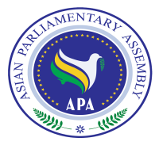
Asian Parliamentary Assembly
APA Troika Plus Meeting on Israeli Atrocities in Palestine
Tehran, 1 June 2010

Agenda
14:00-16:15
Recitations from the Holy Quran
The APA President opens the meeting, and adopts the Agenda
Welcome statement: H. E. Dr. Ali Larijani, Speaker of the Islamic Parliament of Iran
Briefing statement: H.E. Dr. M. H. Nejad-Hosseinian, APA Secretary-General
Key note Address: H.E. Mr. Alie Mazruki, Speaker of the House of Representatives of the Republic of Indonesia and the APA President
Key note Address: H.E. Mr. Mahmoud Abrash, the Speaker of the Parliament of Syrian Arab Republic
Key note address: H. E. Dr. Ali Larijani, Speaker of the Islamic Parliament of Iran
Key note address: H. E. Mr. Tayseer Qubba, Deputy Speaker of Palestine National Parliament
Consideration and adoption of APA Troika Plus Communiqué
The President closes the APA Troika Plus meeting
Joint Press Conference by APA President and other members of the APA Troika

